
Box 926, Toronto Adelaide Retail, Toronto ON M5C2K3

OSC Round Table Discussion on Notice 93-101 regarding Code of Conduct for Derivative Dealers

Recently I attended the OSC Round Table discussing the implementation of Notice 93-101 regarding the Code of Conduct for the new category of derivative dealers. Below is the link to the transcript for this meeting.

http://www.osc.gov.on.ca/en/SecuritiesLaw_oth_20160529_93-101_transcript-roundtable.htm

Any questions or comments can be made directly to the OSC or send me your thoughts and the association will be sending a comment letter to the OSC regarding the legislation.

Kind Regards,

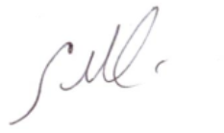
Michael Smith, Co-Chair Carinta Mannarelli, Co-Chair

